ORTHOPAEDIC INSTRUMENTS
Osteotomes, Chisels, Gouges, Strippers
Bone Grafting Gouge with Fibre Handle
Intended Use
The bone grafting gouge with fibre handle is a cortical and cancellous bone harvesting instrument used to harvest autologous bone graft from donor sites such as the iliac crest, proximal humerus, and distal femur in veterinary orthopaedic patients. Autograft harvested with the gouge provides osteogenic, osteoinductive and osteoconductive graft material for fracture non-union and arthrodesis procedures. | 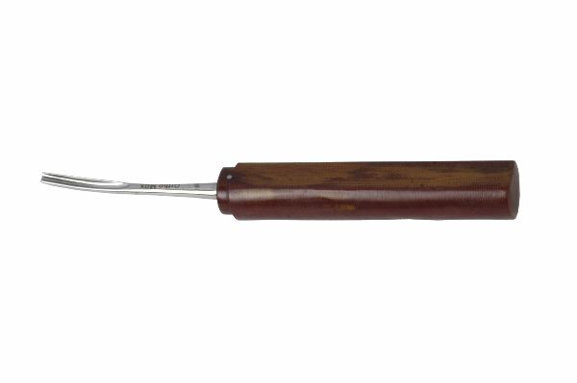
Function
A curved, sharp-edged cup at the working end is impacted into the donor bone using a mallet. The curved lip shears a controlled volume of cancellous or corticocancellous bone that is scooped into the cup interior. The fibre handle provides mallet impact cushioning and a non-slip grip during repeated impaction strokes at the donor site.
Advantages
High-Quality Autograft Harvest: The gouge harvests intact corticocancellous chips that retain viable osteoprogenitor cells and growth factors within the bone matrix, providing superior biologic graft material compared to morselised or milled graft products.
Controlled Volume Removal: The defined cup geometry limits each bite to a fixed volume, allowing the surgeon to harvest the amount of graft needed without creating excessive donor site defects that would weaken the harvest bone.
FAQ
Q: What donor sites are commonly used for bone graft harvesting with a gouge?
A: The proximal humerus (greater tubercle), iliac crest, and distal femoral metaphysis are the most common donor sites in dogs; the iliac crest provides the largest cancellous graft volume per harvest.
Q: How is the gouge sharpened?
A: The inner and outer edges of the cup are honed with a curved slipstone; maintain the original cup curvature during sharpening and avoid flattening the rim profile which reduces cutting efficiency.

ORTHOPAEDIC INSTRUMENTS
Osteotomes, Chisels, Gouges, Strippers
Chisel – Stilli Type
Intended Use
The Stilli-type chisel is a flat-bladed bone cutting instrument used for osteotomy, bone splitting, and cortical bone removal in veterinary orthopaedic procedures. It is indicated for corrective osteotomies, decompressive procedures, and shaping bone surfaces before implant application in dogs and cats. | 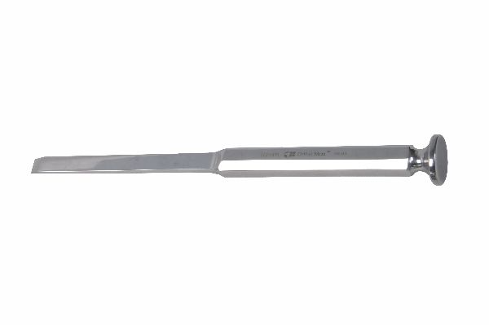
Function
The flat, bevelled blade is driven into bone by mallet impaction on the proximal handle. The single-bevel design causes the blade to track straight through bone when the bevel faces the cut direction, or to deflect slightly when the bevel is oriented away from the cut — a property used to guide osteotomy cuts along planned lines.
Advantages
Precise Osteotomy Control: The flat blade allows the surgeon to follow a pre-planned osteotomy line accurately, particularly for corrective osteotomies such as closing-wedge tibial plateau levelling where exact cut angle determines the degree of slope correction achieved.
Cold Bone Division: Chisel osteotomy generates no thermal damage to the adjacent bone — unlike oscillating saws — preserving the periosteum and osteoprogenitor cells along the osteotomy surface that accelerate biological healing after correction.
FAQ
Q: When is a chisel preferred over an oscillating saw for osteotomy?
A: Chisels are preferred for curved osteotomies, for splitting metaphyseal bone, and in confined spaces where saw-blade access is limited; saws are preferred for long straight cuts in dense cortical bone.
Q: How is chisel sharpness maintained?
A: Hone the bevel face at the original angle on a fine oil stone after each use; a dull chisel requires excessive force, deflects off the planned line, and creates rough bone surfaces that heal more slowly than clean chisel cuts.

ORTHOPAEDIC INSTRUMENTS
Osteotomes, Chisels, Gouges, Strippers
Fine Chisels
Intended Use
Fine chisels are small-profile bone-cutting instruments used for delicate bone splitting, spicule removal, and cortical surface preparation in confined surgical sites during veterinary orthopaedic and reconstructive surgery. They are preferred in feline, toy-breed and miniature breed patients where standard chisels are too large for the anatomical scale. | 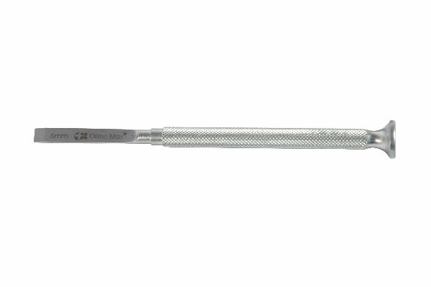
Function
The slim, narrow blade allows access to small anatomical spaces between joints, within vertebral foramina, and around small fracture fragments where standard chisel blades cannot be directed accurately. Light mallet taps drive the fine blade through cortical or dense cancellous bone in controlled small increments.
Advantages
Small Anatomical Compatibility: The reduced blade width and slim profile fit comfortably within the surgical field of toy breeds and cats, allowing bone cutting manoeuvres that standard-size chisels cannot perform without damaging adjacent structures in the confined anatomies of these patients.
Precise Fragment Shaping: Fine chisels create accurately shaped bone surfaces on small fracture fragments where reconstruction plates must seat flush — the narrow blade allows localised shaping without disturbing the fragment's vascular connections on its other faces.
FAQ
Q: What blade widths are available in a fine chisel set?
A: Fine veterinary chisel sets typically include blades of 3 mm, 5 mm, 7 mm and 10 mm width, covering the range from feline spinal to small-breed joint surgery applications.
Q: Are fine chisels used with a mallet?
A: Very fine chisels (3–5 mm) in delicate anatomical locations should be hand-pushed or used with a lightweight mallet; heavy mallet force on fine chisels risks blade fracture in the narrow cross-section.

ORTHOPAEDIC INSTRUMENTS
Osteotomes, Chisels, Gouges, Strippers
Fine Gouge
Intended Use
The fine gouge is a small-diameter, curved bone scooping instrument used to remove cancellous bone in confined spaces during bone grafting, joint preparation, and spinal decompression in veterinary patients. It provides precise cancellous bone removal where full-sized gouges cannot access the target region safely. | 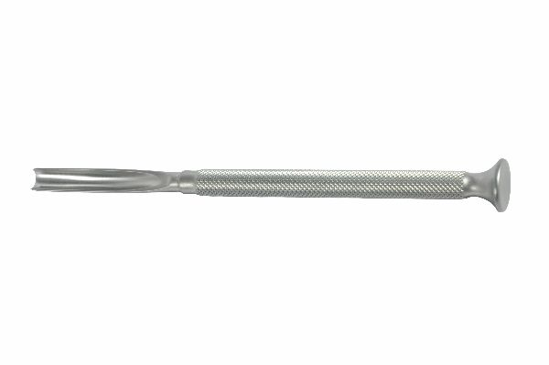
Function
The small, curved cup blade is impacted into bone by light mallet strikes, scooping out defined volumes of cancellous bone per bite. The fine blade dimensions allow work within narrow joint recesses, vertebral windows, and metaphyseal bone tunnels where the surgical target is reached through limited access incisions.
Advantages
Confined-Space Bone Removal: The slim profile and small cup diameter access cancellous bone through narrow cortical windows in spinal procedures, joint arthrodesis and small fragment repair — locations where standard gouges cannot be directed without damaging the surrounding bone margins.
Controlled Cancellous Harvest Volume: The small cup limits each bite to a minimal volume, allowing very precise bone removal around sensitive structures such as spinal cord, joint cartilage, and subchondral bone where over-removal would compromise biological outcomes.
FAQ
Q: How do fine gouges differ from bone scoops?
A: Fine gouges have a sharpened cutting rim that actively cuts bone on impaction; bone scoops are blunter instruments designed to collect loose bone material rather than cut into solid bone structure.
Q: Are fine gouges used in arthroscopic-assisted procedures?
A: Modified fine gouges with extended handles are used in arthroscopic or mini-invasive approaches; standard fine gouges require open access to the bone target.

ORTHOPAEDIC INSTRUMENTS
Osteotomes, Chisels, Gouges, Strippers
Fine Osteotomes
Intended Use
Fine osteotomes are slim, double-bevelled bone-splitting instruments used to divide bone along planned lines in small anatomical regions of veterinary patients. Unlike chisels, their double-bevel geometry cuts straight without lateral deflection, making them ideal for precise osteotomies in small bone segments and delicate anatomical locations. | 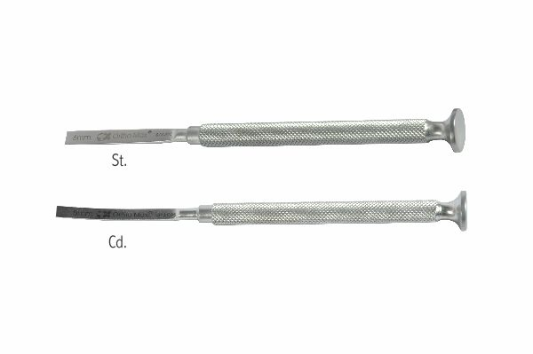
Function
The symmetrical double-bevel creates equal lateral forces during impaction that cancel each other out, causing the blade to track straight without lateral deviation. Light mallet impaction drives the osteotome along the planned division line through cortex and cancellous bone without the directional wandering that single-bevel chisels exhibit.
Advantages
Straight-Line Tracking: The symmetric double-bevel geometry guarantees the osteotome tracks along the planned cut line without lateral drift, critical in precision corrective osteotomies where even 1–2 mm of cut deviation changes the correction angle and compromises the surgical outcome.
Small Patient Application: Fine osteotomes with 3–10 mm blade widths are specifically suited to the small bones of cats and toy breed dogs where standard osteotomes are disproportionately large and would damage adjacent bone structure during use.
FAQ
Q: What is the difference between an osteotome and a chisel?
A: An osteotome has a symmetrical double-bevel and tracks straight; a chisel has a single bevel that causes directional deflection toward the unbevelled face — each property has specific surgical applications.
Q: Can osteotomes be used without a mallet?
A: In very soft metaphyseal bone the osteotome can be hand-pushed; in cortical bone, mallet impaction is required — use controlled taps rather than heavy blows to maintain directional accuracy along the planned cut.

ORTHOPAEDIC INSTRUMENTS
Osteotomes, Chisels, Gouges, Strippers
Gouge Stilli Type – Straight or Curved
Intended Use
The Stilli-type gouge in straight or curved configuration is used for cancellous bone removal, bone tunnelling, and cortical shaping in veterinary orthopaedic surgery. The curved variant accesses anatomical locations that straight gouges cannot reach, such as the posterior acetabulum and the inner aspects of curved bone surfaces. | 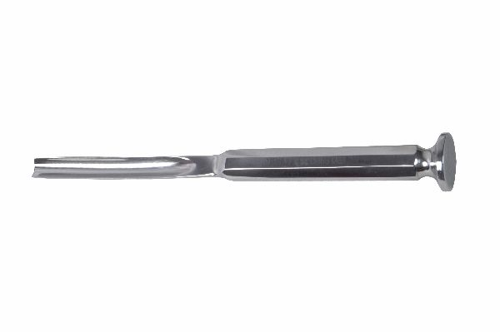
Function
The sharpened U-channel profile blade is impacted into bone by mallet, removing a defined column or wedge of bone material per strike. The straight version creates linear tunnels and channels; the curved version follows anatomical surface curvatures, removing bone along an arc to create curved channels or excavations needed in specific reconstruction procedures.
Advantages
Straight and Curved Access Coverage: Availability in both straight and curved profiles means the surgeon can address bone removal needs in any anatomical orientation without the compromise of using a straight instrument in a curved location that would breach adjacent bone margins.
U-Channel Bone Control: The U-shaped blade profile prevents bone from being pushed laterally as it cuts — the bone material is channelled into the blade, producing a clean-sided excavation with controlled walls that reduce the risk of uncontrolled bone splitting.
FAQ
Q: When is the curved gouge preferred over the straight version?
A: The curved gouge is used when the target bone is on an anatomical arc — such as the acetabular rim, the inner aspect of the femoral head and neck, or the curved posterior vertebral body surface during intervertebral disc procedures.
Q: How deep can the Stilli gouge safely be advanced?
A: Advance only as deep as the direct line of sight permits; blind gouge advancement risks penetrating beyond the target bone into adjacent neurovascular or visceral structures, particularly in spinal and pelvic bone procedures.

ORTHOPAEDIC INSTRUMENTS
Osteotomes, Chisels, Gouges, Strippers
Tessier Osteotome
Intended Use
The Tessier osteotome is a specialised, fine double-bevelled instrument originally designed for craniofacial osteotomy procedures. In veterinary surgery it is used for precise, delicate bone division in craniofacial, nasal, and orbital reconstructive procedures in dogs and cats requiring millimetre-accurate bone cuts in thin, irregular facial bone. | 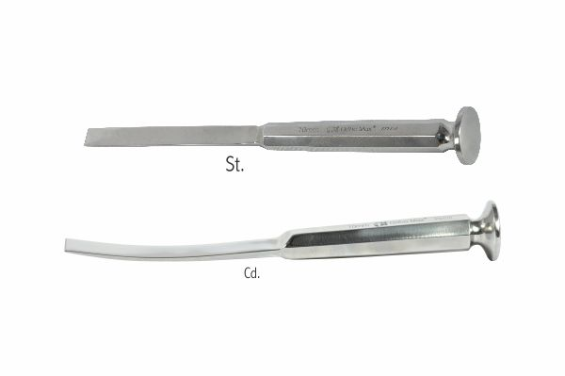
Function
The slim, precisely tapered double-bevel blade slides between bone layers or along planned cut lines in thin craniofacial bone with minimal force. Light mallet taps or hand pressure advances the blade along the planned osteotomy without the cracking and chipping that standard osteotomes cause in the fragile, irregular cortices of facial bones.
Advantages
Facial Bone Precision: The slim blade profile and fine double-bevel of the Tessier osteotome allows bone division in the delicate nasal bones, zygomatic arch and orbital rim of small animals — anatomical regions where standard osteotomes would crack the thin cortex unpredictably.
Minimal Surrounding Bone Disruption: The fine blade edge creates a narrow kerf with minimal lateral force on adjacent bone, preserving the thin cortical plates beside the osteotomy line that must remain intact for successful craniofacial reconstruction.
FAQ
Q: What width Tessier osteotomes are used in veterinary craniofacial surgery?
A: Widths of 3 mm, 5 mm and 8 mm are the most commonly used in veterinary craniofacial procedures; the 3 mm is appropriate for nasal bone work in brachycephalic breeds undergoing corrective rhinoplasty.
Q: Should Tessier osteotomes be used with heavy mallet strikes?
A: No — light, precise taps or hand-push only; heavy strikes in thin facial bone cause unpredictable crack propagation that extends far beyond the planned osteotomy line and complicates the reconstruction.

